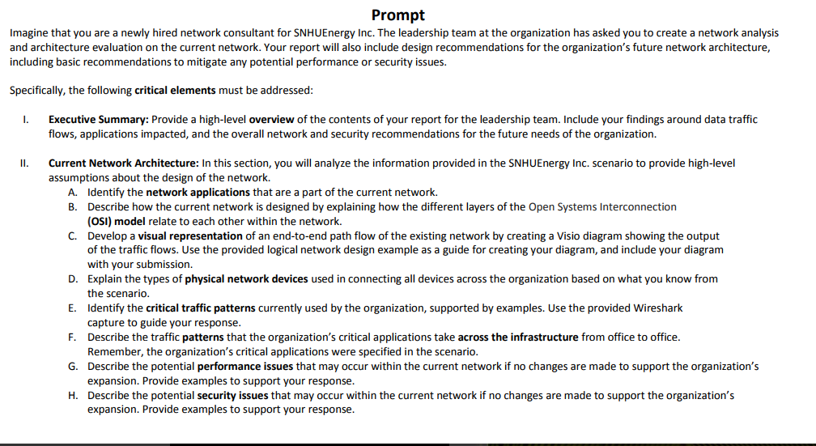
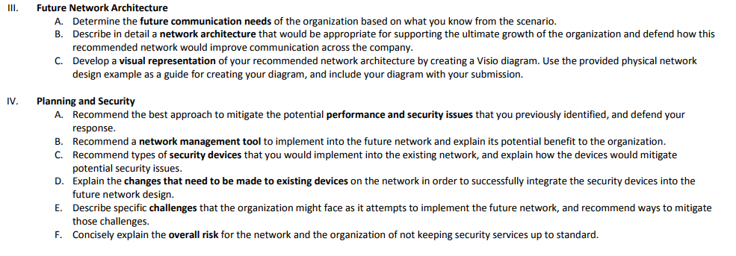
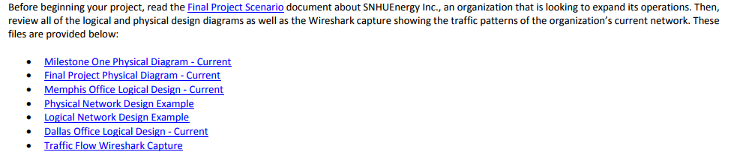
*****Necessary RESOURCES are given below*******
Final Project Scenario
Imagine that you are a newly hired network consultant for SNHUEnergy Inc., a quickly growing oil and gas company that has decided to expand its operation and begin developing a more efficient approach to its use of the currently available technology. As a consultant for the company, you will evaluate the current network architecture, determine any key changes that should occur, and recommend a high-level design for future growth. The leadership team within the company has made a major commitment to the board of directors that they will begin an initiative to create a communication architecture that will allow the company to grow for the next ten years. You have been assigned the task of addressing the overall framework for the architecture and evaluating the basic structure of the network, its communication paths, and the type of traffic utilized. You will also begin to develop a basic security plan in an effort to mitigate any risk the company currently has to internal and external factors.
SNHUEnergy Inc. is a medium-sized oil and gas company that is focused on the discovery and drilling of oil-based products. It wants to grow from company solely focused on exploration into a company that also provides the transportation and refinement of its discoveries. This is a big step for the company, and it wants to make sure the communication infrastructure is ready to deliver in the next 12 to 18 months. The company is currently headquartered in Dallas, Texas, and operates small facilities in the central United States. The total employee count is 120 across the organization, but this will grow by 50% each year for the next two years. Initially, you will evaluate the current logical and physical design of the network to determine the network connectivity, the traffic patterns of the organization, and what would need to occur to enable the business to grow.
The network infrastructure consists of a single building with multiple floors and different divisions (human resources, IT, accounting, and operations and payroll). The company will develop a plan to expand to three additional regional offices in Kansas City and Houston. You will be asked to take the initial design and determine what traffic will need to communicate at each office and which security parameters will need to exist as the company grows. This work will consist of understanding the connectivity and traffic traversing internally and externally and developing a plan to enable end-users to access the correct communication to the key critical applications (i.e., human resources, email, and Voice over Internet Protocol [VoIP]) across the company.
The infrastructure consists of network routers, switches, and firewall equipment that currently connect all the users to the internet internally and externally. All the connectivity between the users is Transmission Control Protocol/Internet Protocol (TCP/IP) traffic, which is utilized by data, voice, and video applications across the organization.
In the future, the company will extend these services across the wide area network (WAN) by using TCP/IP communication processes.

*****We don’t need Milestone one physical diagram*******

Final Project Physical Diagram - Current
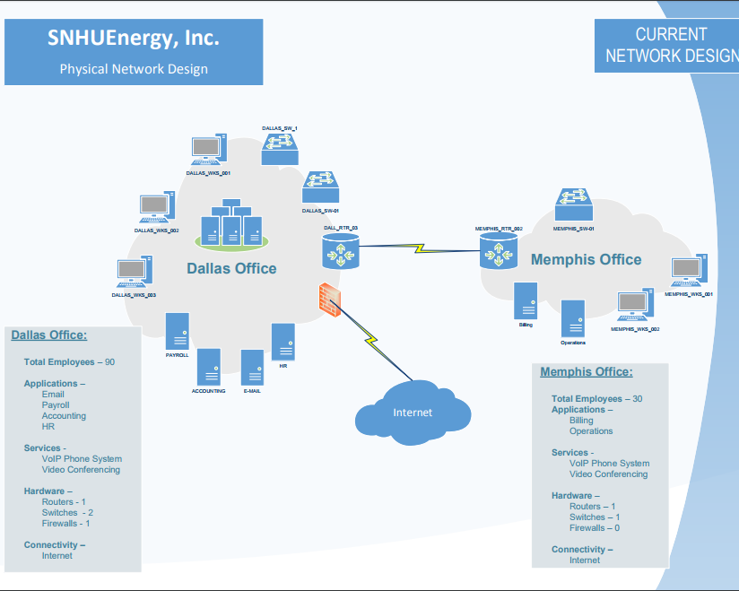

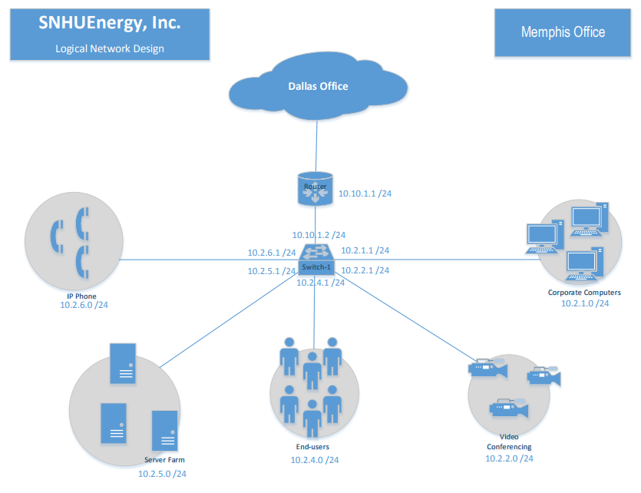
Memphis Office Logical Design - Current

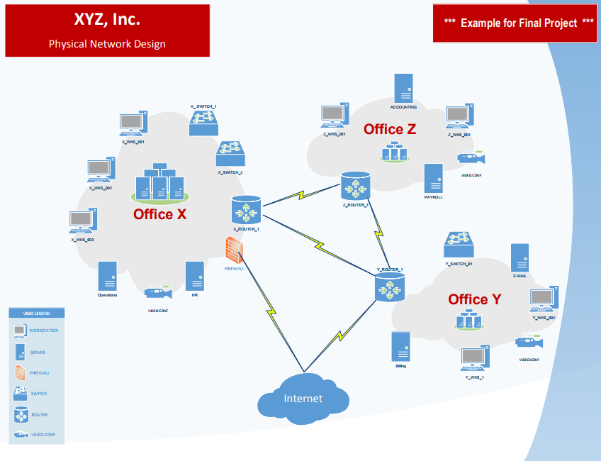
Physical Network Design Example
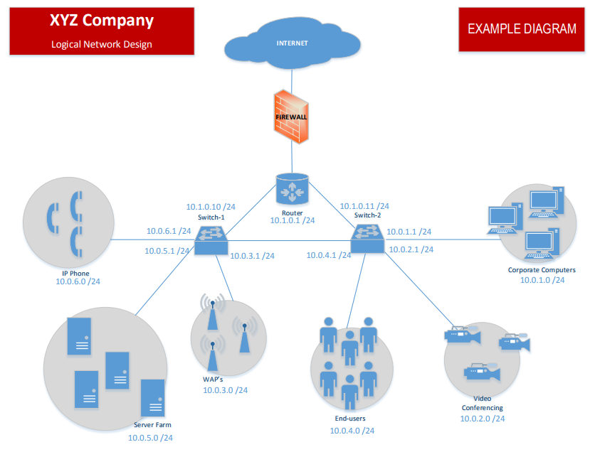
Logical Network Design Example

Dallas Office Logical Design - Current
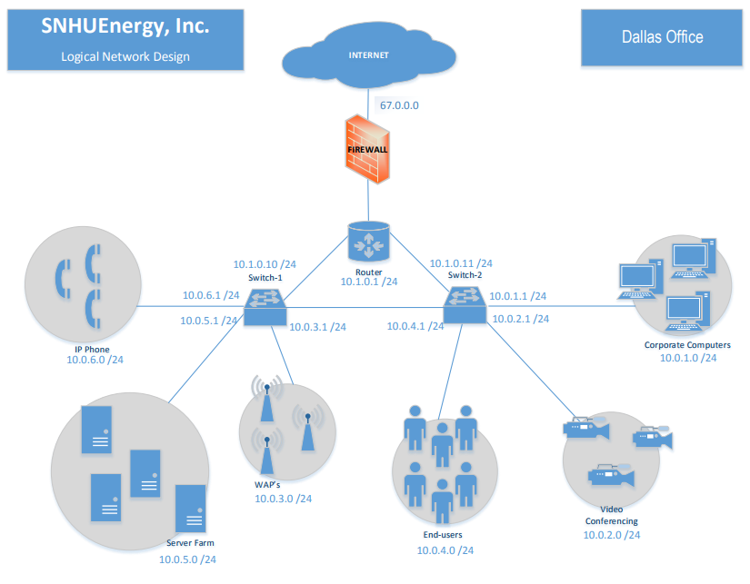

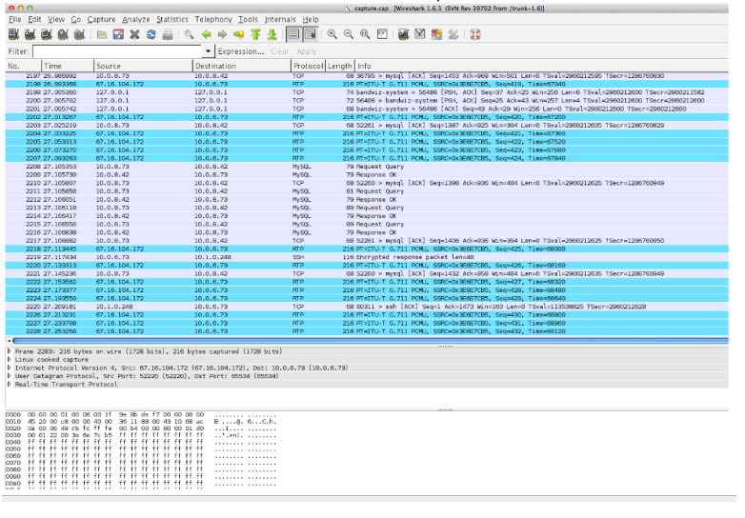
Traffic Flow Wireshark Capture

